**What is AI?**

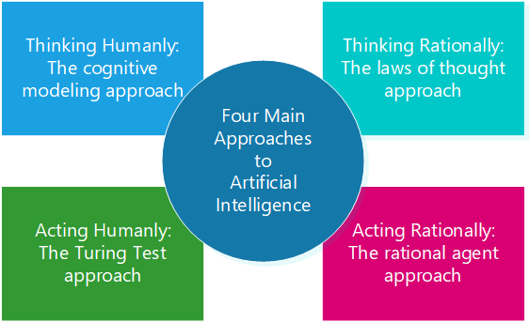

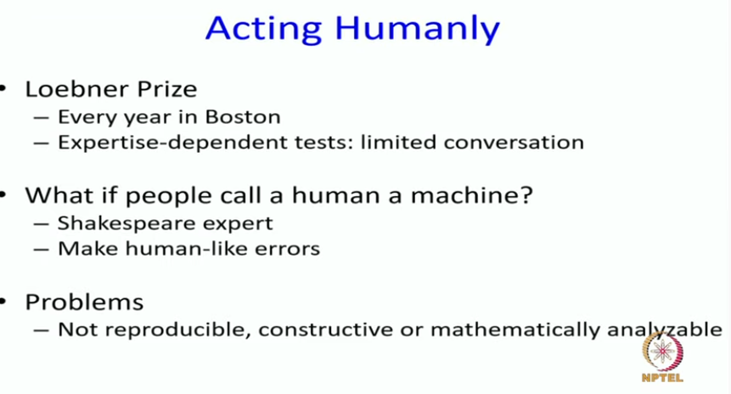

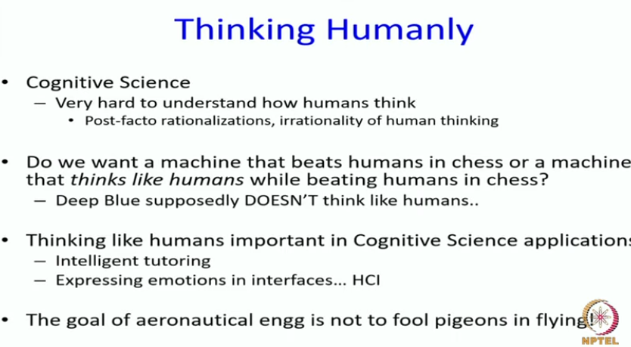

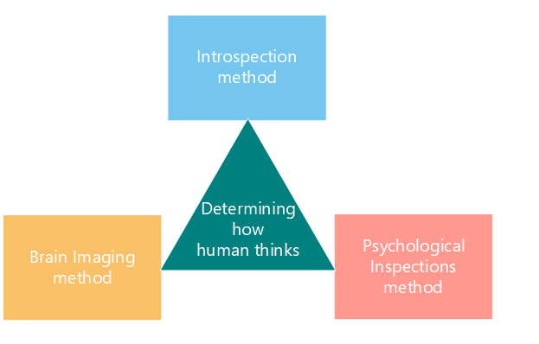

**This requires "getting inside" of the human mind to see how it works and then comparing our computer programs to this**. This is what cognitive science attempts to do. Another way to do this is to observe a human problem solving and argue that one's programs go about problem solving in a similar way.

* Cognitive science is defined as the field of study that interfaces multiple disciplines such as neuroscience, computer science, psychology, artificial intelligence (AI), philosophy, linguistics, and anthropology to understand the cognitive functioning of the human mind and the underlying mental processes. This article explains cognitive science in detail, its essential methods, and the top five applications in the real world. **Linguistics is the scientific study of human language**
* Cognitive researchers aim to develop a deeper understanding of human intelligence and behavior by investigating the functions of nervous systems that involve critical mental faculties such as perception, memory, emotional experience, learning, reasoning, problem-solving, decision-making, and language. The history of cognitive science dates back to the 1950s, coinciding with the emergence of artificial intelligence.

Rel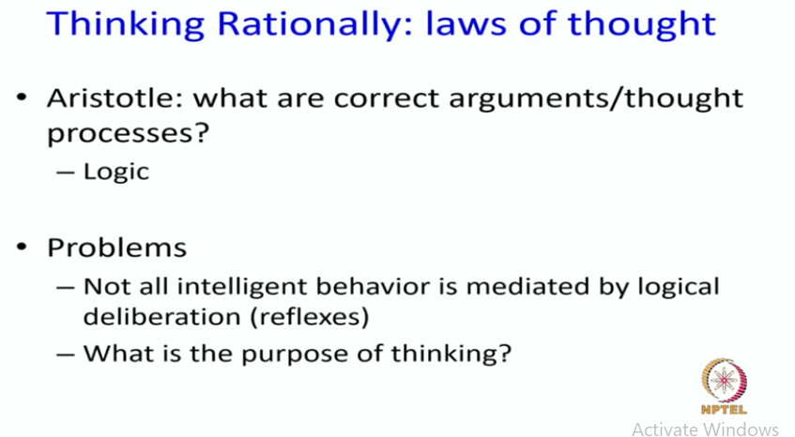

The “thinking rationally” approach to AI **uses symbolic logic to capture the laws of rational thought as symbols that can be manipulated**. Reasoning involves manipulating the symbols according to well-defined rules, kind of like algebra. The result is an idealized model of human reasoning.

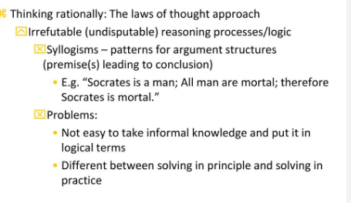

Reflexive knowledge is more important for certain applications

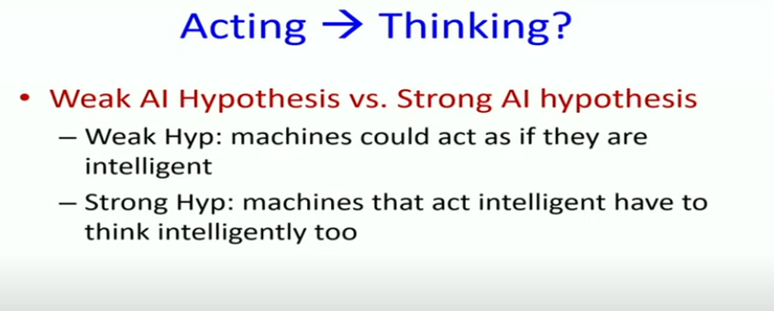

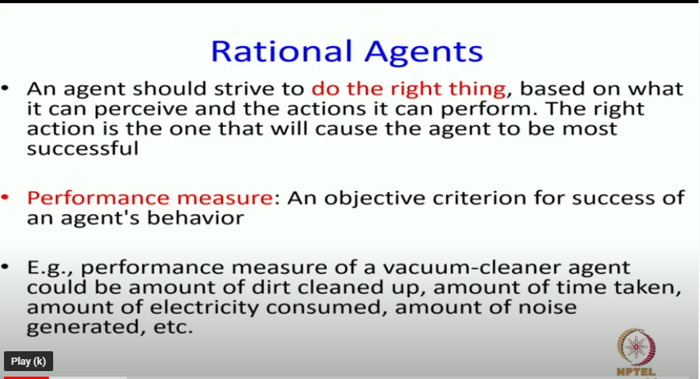

t  “Acting Rationally:  The rational agent approach”.

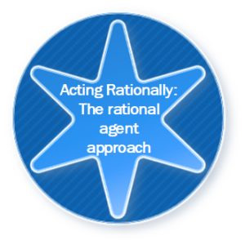

A traditional computer program blindly executes the code that we write. Neither it acts on its own nor it adapts to change itself based on the outcome.

The so-called agent program that we refer to here is expected to do more than the traditional computer program. It is expected to create and pursue the goal, change state, and operate autonomously.

A rational agent is an agent that acts to achieve its best performance for a given task.

The “Logical Approach” to AI emphasizes correct inferences and achieving a correct inference is a part of the rational agent.  Being able to give a logical reason is one way of acting rationally.  But all correct inferences cannot be called rationality, because there are situations that don’t always have a correct thing to do. It is also possible to act rationally without involving inferences. Our reflex actions are considered as best examples of acting rationally without inferences.

The rational agent approach to AI has a couple of advantage over other approaches:

1. A correct inference is considered a possible way to achieve rationality but is not always required to achieve rationality.
2. It is a more manageable scientific approach to define rationality than others that are based on human behavior or human thought.

Today’s [AI](https://gopichandrakesan.com/artificial-intelligence/) concentrates on developing general principles of rational agents rather than achieving perfect rational agents due to complex environments.

However, with the recent developments in supercomputing, 5G, other infrastructures, etc., the superintelligence rational agents are available and increasing now.

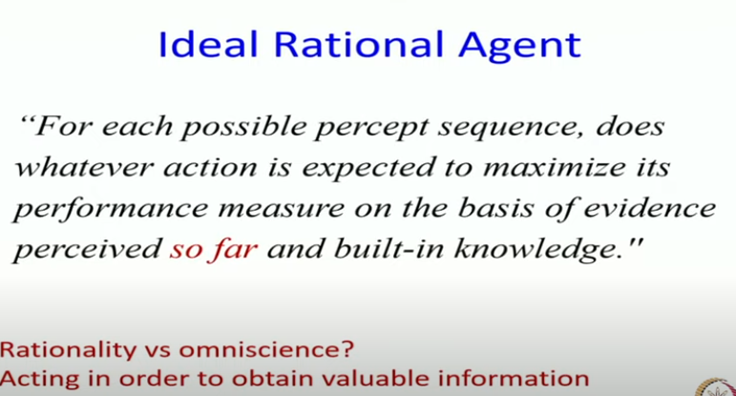

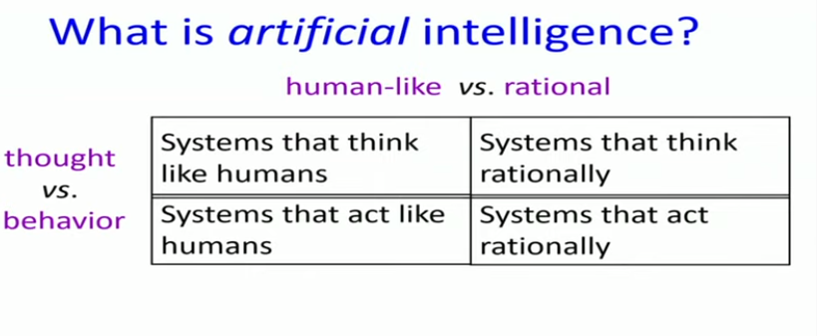 

Think Rationally: https://www.gopichandrakesan.com/thinking-rationally-the-laws-of-thought-approach-artificial-intelligence/